**Assignment 6: Practice – Automating Tasks with Blender Scripting + Marketing Strategy & ROI**

**Instructor:** Professor Leonardo Moura  
**Course:** Game Content Creation  
**Topic:** Assignment – 6  
**Date:** June 16, 2025  
  
**Group-4 Members:**  
Kavya Shah  
Divya Rana  
Gaurav Vedak  
Veysel Toprak  
Srujal Patel

**Part 1: Blender Scripting Explanation**

For this part of the assignment, we were asked to utilize Python scripting in Blender to enhance the efficiency and ease of our work. Since our game ***Whispers of Light*** includes a lot of repeated objects like lanterns and memory pieces, we thought it would be smart to write scripts that help us place those objects quickly and give them materials automatically.

We picked two tasks to automate:

1. Placing objects in a circle.
2. Giving objects a glowing material through code.

**1. Placing Objects in a Circle**

In many scenes of our game, we use lanterns or other glowing items arranged in a circular shape—especially near shrines or special memory areas. Before scripting, we used to place these objects manually, which took time and was hard to get perfect. We had to guess the spacing or use trial and error to make the circle look even.

So, we wrote a Python script to do this for us. The script lets us choose how many lanterns we want, the distance between them (called the radius), and the name of the object we’re placing. The script utilizes simple math (such as sine and cosine) to determine the position of each lantern within a circle.  
  
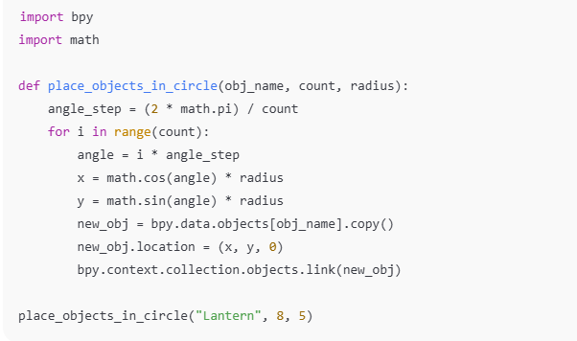  
When we run this in Blender, it automatically creates 8 copies of the lantern and places them in a circle with a radius of 5 units. This was super helpful because it saved time, and everything looked perfectly spaced and even.

**2. Applying Glowing Material with Code**

The second task we automated was applying a special material to some objects. In our game, we use glowing glass-like materials on things like the broken mirror pieces or light-based objects. Normally, we would make this material by hand using Blender’s node editor, but that can get repetitive—especially if we need to apply it to lots of different items.

Instead, we wrote a Python script to create the material and apply it automatically. The script creates a new material called “GlassGlow” and uses nodes like Glass BSDF and Emission to make it look like it glows and has transparency.

Here’s a short part of that code:

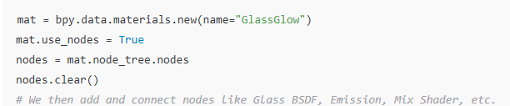  
  
This made it easier to keep our materials consistent. If we wanted to change the glow colour or brightness, we could just adjust the script once and apply it again. It also meant we didn’t forget anything or make small mistakes when setting up the look of an object.

**What Was Difficult**

At the beginning, using Python in Blender was a bit confusing. We weren’t used to creating nodes with code, especially since the node editor is usually very visual. We had to search for examples online and test different things before it finally worked. Sometimes the objects wouldn’t appear, or the material wouldn’t connect right.

Another challenge was making sure copied objects were placed in the right place and added to the scene properly. If we didn’t link the new object back to the collection, it wouldn’t show up.

But after trying a few times and reading the documentation, we figured it out. We also helped each other understand what different parts of the code were doing.  
  
**What We Learned**

These two scripts helped us finish our scenes faster and more accurately. We no longer had to guess where things should go or waste time copying and placing objects one by one. It also helped us understand how to use Blender’s Python tools for future projects.

Now that we’ve done this, we feel more confident in using code to help with Blender tasks. We’d like to explore even more scripting in the future—maybe to animate objects, export files automatically, or even create our tools.

Using Blender scripting saved us time, improved the quality of our game scenes, and made our workflow smoother. We think it’s a great skill to have as game design students.

**Part 2: Marketing Strategy and ROI**

**Marketing Strategy**

**Target Audience**

Our game, *Whispers of Light*, is designed for players who enjoy calm, story-rich, and emotionally immersive games. These are people looking for meaningful exploration rather than high action. Our main audience is players aged **16 to 30**, who enjoy artistic games with deep narratives and relaxing gameplay.

We expect our audience to be familiar with games like *Gris*, *Journey*, *Spiritfarer*, and *Ori and the Blind Forest*. These games are known for their visuals, sound design, and strong emotions—all of which we are focusing on too.

Most of our audience is active on platforms like **Steam, itch.io**, and social media sites like **YouTube, TikTok, and Instagram**. Many of them follow indie games and like to support creative student or small team projects.

**Marketing Platforms**

We’re using affordable platforms that are perfect for indie games:

**1. TikTok and Instagram Reels**  
We’ll post short videos showing key gameplay moments, glowing effects, and peaceful environments.

**2. YouTube Devlogs**  
We’ll create short behind-the-scenes videos showing our process—like building assets, creating levels, or testing new mechanics.

**3. Discord Server**  
We’ll build a small community where players can join, stay updated, and give feedback. It helps build long-term loyalty.

**4. Indie Game Blogs and Press Kits**  
We’ll prepare a press kit with images, game details, and a summary, and send it to sites like IndieDB or AlphaBetaGamer.

**5. Reddit and Indie Forums**  
Communities like **r/IndieGaming** and **r/GameDev** will help us share progress, ask for feedback, and gain visibility.

These platforms are **free or very low-cost**, making them perfect for our student project.

**Game Identity and Branding**

The theme of *Whispers of Light* is personal discovery through memory and light. The story is quiet but emotional, focused on healing and self-reflection. Players move through environments that represent memories, using light to uncover paths and solve puzzles.

Our tagline is:  
**“A luminous journey through forgotten memories.”**

The game uses a **soft, glowing art style**, with slow, peaceful music and calming visuals. It’s not about fast action—it’s about mood and connection.

What makes our game different is how we blend visual storytelling, glowing art, and a quiet emotional message. That’s our unique identity.

**Marketing Goals**

**Before Launch Goals**

* 500+ social media followers
* 100+ players on Discord
* Be featured on at least 2 indie gaming blogs
* Run a private beta with feedback from 20+ testers
* Release a short playable demo

**After Launch Goals**

* Reach 1,000 downloads in the first 3 months
* Get 80%+ positive reviews
* Build a small but loyal community that follows future updates or new projects

These goals are realistic for our size and budget and will help us grow the game organically.

**ROI (Return on Investment) – in CAD**

**Revenue Plan (CAD)**

We will sell the game for **$6.99 CAD** on **itch.io**. It’s a fair price for a short but polished indie game.

Here are our revenue estimates:

* 1,000 sales × $6.99 = **$6,990 CAD**
* 2,500 sales × $6.99 = **$17,475 CAD**

We may also offer a **Pay What You Want** model, where some players might pay extra to support us. This can help raise more funds beyond regular sales.

Additional possible income sources:

* Small donations on itch.io
* Bundle deals with other indie games
* Monetized YouTube devlog channel

**Estimated Costs (CAD)**

Even though we use free software like Blender, there are still a few costs:

|  |  |
| --- | --- |
| Item | Estimated Cost (CAD) |
| Blender (free) | $0 |
| Unity license (if upgraded later) | $250 |
| Sound/music assets | $150 |
| Promo visuals and editing tools | $100 |
| Social media ads (optional) | $100 |
| Store fees / payment processing | $100 |
| Total Estimated Cost | **$700 CAD** |

These are small amounts, but still important. If we have extra funds later, we might hire someone for custom music or additional polish.

**Break-Even Estimate (CAD)**

To cover our **$700 CAD** budget, we would need to sell:

* $700 ÷ $6.99 ≈ **101 copies**

So, if we can sell just **100–110 copies**, we will break even. We believe this is realistic within the **first 1 to 2 months** of launch if we follow our marketing plan and reach the right audience.

**Why It’s a Good Investment**

*Whispers of Light* might be a student project, but we’ve developed it like a real indie release. It’s carefuenjoysesigned, emotionally rich, and has a polished look that players in this niche enjoy. The game is built with a clear identity and message—and developed using free and efficient tools.

For a low development cost of **$700 CAD**, the game could easily become profitable in a short time. We’re not aiming to be the next big AAA studio—we’re aiming to connect with a loyal audience who appreciates what we’re building.

If we continue to update the game, release small expansions, or start a new project using the same tools and team, we already have the foundation to succeed again. That’s why *Whispers of Light* is a smart starting point, not just for this assignment, but for future opportunities too.